MEMORANDUM OF AG REEMENT BETWEEN THE BOARD OF COOPERATIVE EDUCATIONAL SERVICES, SOLE SUPERVISORY DISTRICT OF WESTCHESTER AND THE BOCES TEACHERS' ASSOCIATION

WHEREAS, the Board of Cooperative Educational Services, Sole Supervisory District of Westchester and the BOCES Teachers' Association are parties to a Collective Bargaining Agreement between them; and
WHEREAS, the parties wish to amend its Collective Bargaining Agreements based upon a negotiations had between the parties;
WHEREAS, it is understood that the following agreement is subject to ratification by both the BTA and the BOCES Board of Education;
Now, IT IS HEREBY AGREED by and between the Parties that Article XIX - Compensation, Section F - Summer Employment is amended as follows:
1 . Teachers employed by the Board for a full six (6) hours for summer school during July and/or August shall be paid at a rate of l/270th of his or her previous year's base salary, up to a maximum of three hundred and sixty-five dollars ($365.00) per day.
- Teaching Assistants employed by the Board for a full six (6) hours for summer school during July and/or August shall be paid at a rate of 1/270th of his or her previous year's base salary, up to a maximum of one hundred and fifty dollars ($150.00) per day.
- Teacher Aides employed by the Board for a full six (6) hours for summer school during July and/or August shall be paid at a rate of l/270lh of his or her previous year's base salary, up to a maximum of one hundred and twenty-five dollars ($125.00) per day.
- Unit members will be given the right of first refusal for summer school position(s) for a title they hold during the school year, provided that during the school year in which the summer school appointment is made, the unit member:

13611071322178 VI 4/8/15

- Has used no more than eight (8) sick days

- Has not used any unpaid (payroll dock) days

- Has not been subject to disciplinary action, nor received more than two (2) counseling memoranda
5. This agreement will be incorporated into the collective bargaining agreements for the respective titles should the BTA and the BOCES come to an agreement on the full terms of a successor agreement between the BTA and the BOCES which expires on June 30, 2015. Should terms of a successor agreement not be reached by December 31, 2015, December 31, 2016 this agreement shall sunset on December 31, 2015 December 31, 2016.

BOCES Teachers' Association Board of Cooperative Educational Services, Sole Supervisory District of Westchester

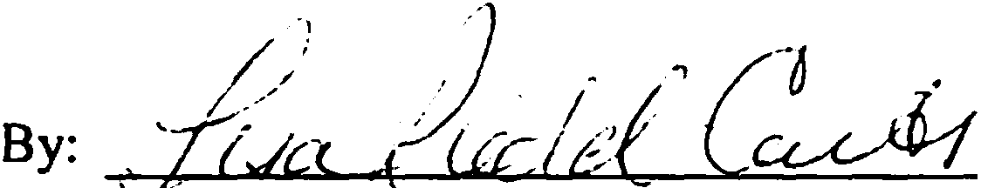 By:
,
Dated: /' ,2015

1361107/322178 VI 3/25/IS

